Association Rule in Data Mining
Association Rule Mining is a data mining technique used to find relationships or correlations among items in large transactional databases. It helps answer questions like:
“If a customer buys item X, how likely are they to buy item Y?”
This technique is most famously used in market basket analysis — e.g., finding that “70% of customers who buy bread also buy butter.”
Structure of an Association Rule
A rule is generally written as: X → Y where X and Y are itemsets. X denotes the antecedent (if-part) and Y denotes the consequent (then-part)
Example: Bread → Butter means customers who buy Bread are likely to buy Butter.
Association Rule Metrics
To evaluate the strength of association rules, three key measures are used:
(a) Support - Support shows how frequently the rule occurs in the dataset.
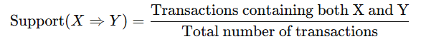
Support tells how popular (frequency of both items) the rule is in the overall dataset.
(b) Confidence - shows how often items in Y appear in transactions that contain X.
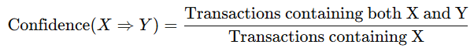
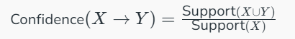
It measures the reliability of the inference made by the rule.
(c) Lift - measures how much more likely Y is bought when X is bought.
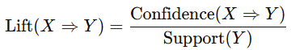
It is the ratio of the observed support to that expected if X and Y were expected (measures the degree of corelation between Xand Y).
If Lift > 1 → positive correlation between X and Y (items occur together more than expected)
If Lift = 1 → X and Y are independent.
If Lift < 1 → negative correlation.
Numerical Problem- A store has the following transaction data:
Transaction ID | Items Purchased
T1 | Milk, Bread, Butter
T2 | Bread, Butter
T3 | Milk, Bread
T4 | Milk, Bread, Butter
T5 | Bread, Butter
Find the Support, Confidence, and Lift for the rule: Bread → Butter
Solution Step 1: Total Transactions
Total = 5
Step 2: Count occurrences
- Transactions containing Bread = T1, T2, T3, T4, T5 → 5
- Transactions containing Butter = T1, T2, T4, T5 → 4
- Transactions containing Bread and Butter = T1, T2, T4, T5 → 4
Step 3: Compute Metrics
(a) Support of Rule
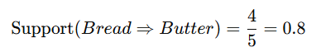
→ 80% of all transactions contain both Bread and Butter.
(b) Confidence of Rule
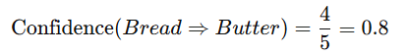
→ When Bread is bought, Butter is also bought 80% of the time.
(c) Lift of Rule
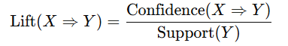
Since Lift = 1, Bread and Butter are independent — buying Bread does not particularly increase or decrease the likelihood of buying Butter.
5. Interpretation
- High Support (0.8) → Rule is common.
- High Confidence (0.8) → Rule is reliable.
- Lift = 1.0 → No extra influence; items are independent.
Problem 2: Multi-Item Antecedent Rule
TID | Items Purchased
T1 | Milk, Bread, Butter, Eggs
T2 | Bread, Butter
T3 | Milk, Bread, Butter
T4 | Bread, Eggs
T5 | Milk, Bread, Eggs
Find Support, Confidence, and Lift for the rule (Milk, Bread) → Butter
Solution
- Total transactions = 5
- Transactions with (Milk & Bread) = T1, T3, T5 → 3
- Transactions with (Milk, Bread & Butter) = T1, T3 → 2
- Transactions with (Butter) = T1, T2, T3 → 3
Support= Transactions with (Milk, Bread & Butter) ÷ Total transactions = 2/5= 0.4(40%)
Confidence = 2/3 = 0.667 (67%)
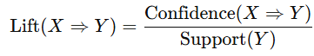
Lift = 2/3 ÷ (3/5) = 10/9 = 1.11 which is > 1, implies a positive association.
Interpretation: When both Milk and Bread are bought, customers are 11% more likely to buy Butter than average → slight positive association.
Problem 3: Complex Case — Multi-item Consequent
TID | Items Purchased
T1 | Bread, Butter, Milk, Eggs
T2 | Bread, Milk
T3 | Bread, Butter
T4 | Milk, Eggs
T5 | Bread, Butter, Eggs
Find Support, Confidence, and Lift for the rule Milk → (Bread, Butter)
Solution
- Total transactions = 5
- Transactions with Milk = T1, T2, T4 → 3
- Transactions with Bread & Butter = T1, T3, T5 → 3
- Transactions with Milk, Bread & Butter = T1 → 1
Support = 1/5 = 0.2(20%)
Confidence = 1/3 = 0.333
Lift = 1/3 ÷ 3/5 = 5/9 = 0.555 which is < 1
Interpretation: Lift < 1 → Customers who buy Milk are less likely to buy both Bread and Butter together compared to the general population.
Problem 4: Comparing Two Rules
TID | Items Purchased
T1 | Pen, Notebook, Eraser
T2 | Pen, Notebook
T3 | Pen, Eraser
T4 | Notebook, Pencil
T5 | Pen, Notebook, Pencil
Compare rules: Pen → Notebook and Notebook → Pen.
Solution : The total transactions = 5
Transactions with Pen = T1, T2, T3, T5 → 4
Transactions with Notebook = T1, T2, T4, T5 → 4
Transactions with both = T1, T2, T5 → 3
For Rule 1 : Pen → Notebook
Support = 3/5 = 0.6
Confidence = 3/4 = 0.75
Lift = 0.75 / 0.8 = 0.9375
For Rule 2 : Notebook → Pen
Support = 0.6
Confidence = 3/4 = 0.75
Lift = 0.75 / 0.8 = 0.9375
Interpretation: Both rules are symmetric, and Lift < 1 → slightly negative correlation

Apriori Algorithm in Data Mining
It is a basic method used in DM to find groups of items that often appear together in large sets of data. It helps to discover useful patterns or rules about how items are related which is particularly valuable in market basket analysis. Like in a grocery store if many customers buy bread and butter together, the store can use this information to place these items closer or create special offers. This helps the store sell more and make customers happy
This algorithm is one of the most fundamental algorithms in data mining, specifically used for association rule learning — to find frequent itemsets and derive meaningful association rules (like “Customers who buy bread also buy butter”).
It is based on the principle that:
“All subsets of a frequent itemset must also be frequent.”
This principle is called the Apriori property.
Objective: To find
- All frequent itemsets that occur above a given minimum support threshold.
- Strong association rules that have confidence above a given minimum confidence threshold.
Key Concepts and Formulas
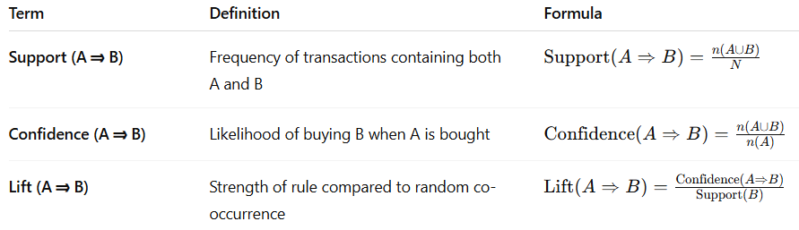
Steps of the Apriori Algorithm
- Set minimum support (min_sup) and minimum confidence (min_conf) thresholds.
- Generate all 1-itemsets and count their frequency.
- Prune itemsets that do not meet min_sup.
- Use frequent itemsets of size k to generate candidate itemsets of size (k+1) (self-join).
- Count frequency of these candidates and again prune those not meeting min_sup.
- Continue until no more frequent itemsets can be generated.
- From the frequent itemsets, generate strong association rules using the min_conf threshold.

Numerical Example
TID | Items Purchased
T1 | Milk, Bread, Butter
T2 | Bread, Butter
T3 | Milk, Bread
T4 | Milk, Bread, Butter
T5 | Bread, Butter, Eggs
Given: Min. Support = 60% (i.e., 0.6), Min. Confidence = 70% (i.e., 0.7) and transactions = 5
Step 1 : Generate 1-itemsets
Item | Count | Support
Milk | 3 | 3/5 = 0.6
Bread | 5 | 5/5 = 1.0
Butter | 4 | 4/5 = 0.8
Eggs | 1 | 1/5 = 0.2
Step 2: Generate 2-itemsets
Possible pairs: (Milk, Bread), (Milk, Butter), (Bread, Butter)
Itemset | Count | Support
(Milk, Bread) | 3 | 0.6
(Milk, Butter) | 2 | 0.4
(Bread, Butter) | 4 | 0.8
Frequent 2-itemsets: (Milk, Bread), (Bread, Butter) as they meet minimum support criteria
Step 3: Generate 3-itemsets
Possible 3-itemset: (Milk, Bread, Butter)
Itemset | Count | Support
(Milk, Bread, Butter) | 2 | 0.4
Not frequent (Support = 0.4 < 0.6)
Final frequent itemsets: {Milk}, {Bread}, {Butter}, {Milk, Bread}, {Bread, Butter}

Step 4: Generate Association Rules
From 2-itemsets, we can derive:
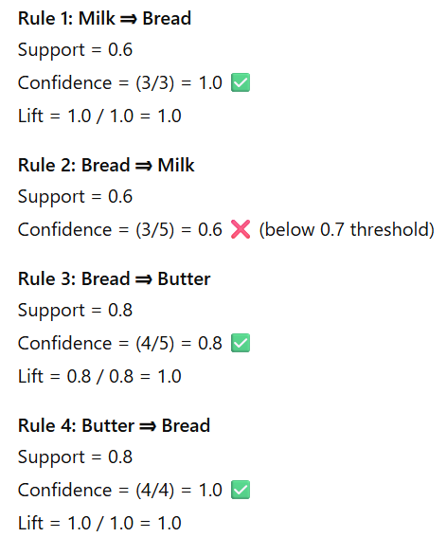
Strong Rules (min_conf ≥ 0.7):
Milk ⇒ Bread (Confidence = 1.0)
Bread ⇒ Butter (Confidence = 0.8)
Butter ⇒ Bread (Confidence = 1.0)
Interpretation
- Milk ⇒ Bread → Every customer who buys Milk also buys Bread.
- Butter ⇒ Bread → Butter sales are always accompanied by Bread purchases.
- Bread ⇒ Butter → Most Bread buyers also buy Butter (80% of the time).
These insights help in cross-selling and product placement strategies.
Summary table
Rule | Support | Confidence | Lift | Strength
Milk ⇒ Bread | 0.6 | 1.0 | 1.0 | Strong
Bread ⇒ Butter | 0.8 | 0.8 | 1.0 | Strong
Butter ⇒ Bread | 0.8 | 1.0 | 1.0 | Strong
- Apriori uses the “subset” property to reduce computation.
- It is bottom-up — starting with 1-itemsets and building up.
- Performance depends on support/confidence thresholds.

Regression Analysis in Data Mining
Regression Analysis is a predictive modeling technique used to understand the relationship between a dependent variable (target) and one or more independent variables (predictors). In data mining, regression is used to forecast trends, predict numeric outcomes, and analyze relationships between variables — for example:
- Predicting sales revenue based on advertising expenditure.
- Estimating house prices based on size, location, and number of rooms.
- Forecasting stock prices based on past data.
Purpose of Regression Analysis in Data Mining
Regression is part of predictive analytics, and it helps in:
- Prediction: Estimating future or unknown values.
- Trend Analysis: Understanding how variables change over time.
- Relationship Identification: Measuring how strongly variables are related.
- Optimization: Finding values that maximize or minimize outcomes.
Types of Regression Used in Data Mining
Type | Description | Example
Linear Regression | Relationship between variables is linear (straight-line). | Predicting sales based on advertising spend.
Multiple Linear Regression | More than one independent variable. | Predicting house prices based on area, rooms, location.
Logistic Regression | Used when the dependent variable is categorical (e.g., Yes/No). | Predicting if a customer will buy a product.
Polynomial Regression | Non-linear relationships fitted by higher-order equations. | Predicting growth rates or curved trends.
Linear Regression Model
The simplest regression is the Simple Linear Regression, represented as: Y=a + bX + ε
Where Y is the dependent variable (Predicted variable), X is the independent variable (Predictor), a is the Intercept (value of Y when X = 0), b is the regression coefficient or slope of the line and ε denotes Error term (unexplained variation) which is assumed as zero. So, the regression line of Y on X is written as Y=a + bX, where a, b are to be determined using the dataset values of (X,Y).
Numerical Problem:
A marketing manager wants to understand how advertising expenditure (X) affects sales revenue (Y). The data collected from 5 months is:
Month | Advertising (X in ₹’000) | Sales (Y in ₹’000)
1 | 2 | 4
2 | 3 | 5
3 | 5 | 7
4 | 7 | 10
5 | 9 | 15
Find the regression equation and predict sales when advertising = ₹6,000.
SOLUTION : Step 1: Compute Required Values
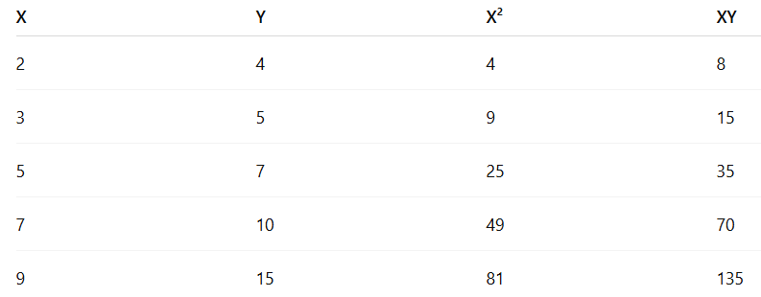
Step 2: Find the Slope (b)
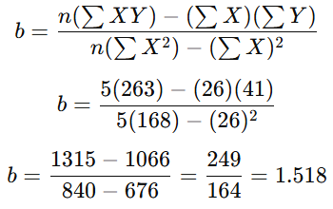

Step 3: Find the Intercept (a)
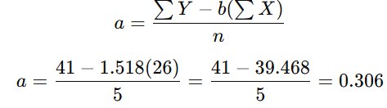
Step 4: Regression Equation
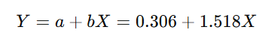
Step 5: Prediction
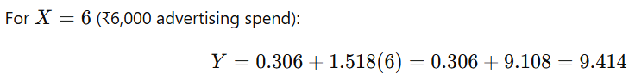
Predicted Sales = ₹9.41 thousand = ₹9410
Interpretation
- Slope (b = 1.518): For every ₹1,000 increase in advertising, sales increase by ₹1.518 thousand.
- Intercept (a = 0.306): When advertising is zero, sales are expected to be ₹0.306 thousand.
- Thus, there is a strong positive linear relationship between advertising and sales.
Uses of Regression Analysis in Data Mining
Area | Application
Marketing | Predicting sales, demand forecasting
Finance | Credit scoring, stock price prediction
Operations | Resource optimization, capacity planning
HR Analytics | Salary prediction, performance analysis
Healthcare | Predicting patient outcomes or treatment costs
Conclusion:
- Regression is a supervised learning technique used for numeric prediction.
- The strength of prediction depends on correlation between variables.
- It is a foundational method for predictive analytics, trend forecasting, and decision support systems.

PROBLEM 2 ON REGRESSION
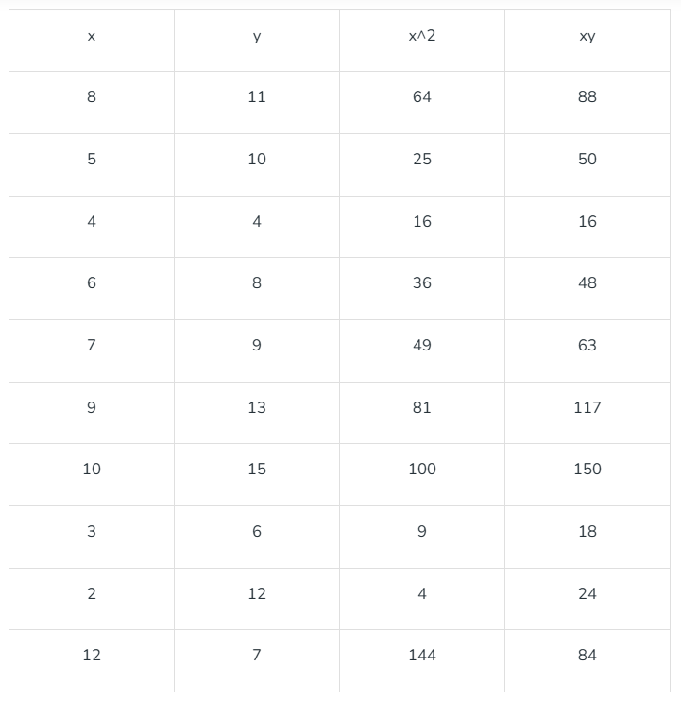

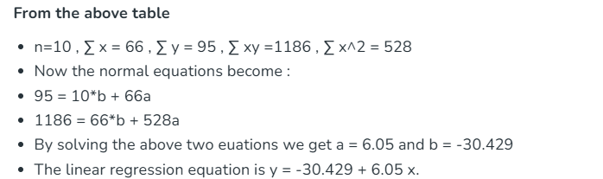

Machine Learning - Machine learning is a growing technology which enables computers to learn automatically from past data. Machine learning uses various algorithms for building mathematical models and making predictions using historical data or information. Currently, it is being used for various tasks such as image recognition, speech recognition, email filtering, Facebook auto-tagging, recommender system, and many more.
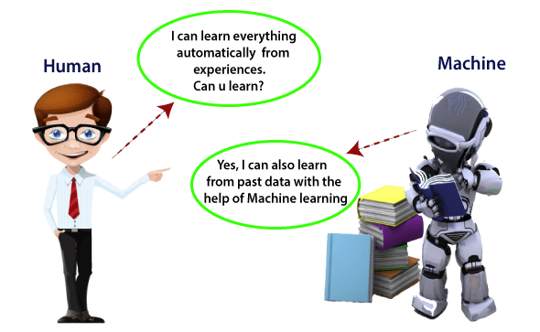
Machine Learning is said as a subset of AI that is mainly concerned with the development of algorithms which allow a computer to learn from the data and past experiences on their own. Arthur Samuel, an early American leader in the field of computer gaming and artificial intelligence, coined the term “Machine Learning ” in 1959 while at IBM. He defined machine learning as “the field of study that gives computers the ability to learn without being explicitly programmed “. However, there is no universally accepted definition for machine learning
Machine learning enables a machine to automatically learn from data, improve performance from experiences, and predict things without being explicitly programmed.
There are several types of machine learning, including supervised learning, unsupervised learning, and reinforcement learning.

How does Machine Learning work
A Machine Learning system learns from historical data, builds the prediction models, and whenever it receives new data, predicts the output for it. The accuracy of predicted output depends upon the amount of data, as the huge amount of data helps to build a better model which predicts the output more accurately.
Suppose we have a complex problem, where we need to perform some predictions, so instead of writing a code for it, we just need to feed the data to generic algorithms, and with the help of these algorithms, machine builds the logic as per the data and predict the output. Machine learning has changed our way of thinking about the problem.
The below block diagram explains the working of Machine Learning algorithm:
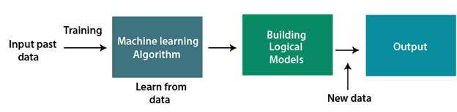

Features of Machine Learning:
- Machine learning uses data to detect various patterns in a given dataset.
- It can learn from past data and improve automatically.
- It is a data-driven technology.
- ML is much similar to data mining as it also deals with the huge amount of the data.

Need for Machine Learning
The need for ML is increasing day by day. The reason behind the need for ML is that it is capable of doing tasks that are too complex for a person to implement directly. As a human, we have some limitations as we cannot access the huge amount of data manually, so for this, we need some computer systems and here comes the machine learning to make things easy for us.
We can train ML algorithms by providing them the huge amount of data and let them explore the data, construct the models, and predict the required output automatically. The performance of the machine learning algorithm depends on the amount of data, and it can be determined by the cost function. With the help of machine learning, we can save both time and money.
The importance of ML can be easily understood by its use-cases. Currently, ML is used in self-driving cars, cyber fraud detection, face recognition, and friend suggestion by Facebook, etc. Various top companies such as Netflix and Amazon have built ML models that are using a vast amount of data to analyze the user interest and recommend product accordingly.

Following are some key points which show the importance of ML :
- Rapid increment in the production of data
- Solving complex problems, which are difficult for a human
- Decision making in various sector including finance
- Finding hidden patterns and extracting useful information from data.

Classification of Machine Learning
At a broad level, machine learning can be classified into three types:
- Supervised learning
- Unsupervised learning
- Reinforcement learning

Supervised Learning
Supervised learning is a type of ML method in which we provide sample labelled data to the machine learning system in order to train it, and on that basis, it predicts the output.
The system creates a model using labelled data to understand the datasets and learn about each data, once the training and processing are done then we test the model by providing a sample data to check whether it is predicting the exact output or not.
The goal of supervised learning is to map input data with the output data. The supervised learning is based on supervision, and it is the same as when a student learns things in the supervision of the teacher. The example of supervised learning is spam filtering. Supervised learning can be grouped further in two categories of algorithms:
- Classification
- Regression

Unsupervised Learning
Unsupervised learning is a learning method in which a machine learns without any supervision.
The training is provided to the machine with the set of data that has not been labeled, classified, or categorized, and the algorithm needs to act on that data without any supervision. The goal of unsupervised learning is to restructure the input data into new features or a group of objects with similar patterns.
In unsupervised learning, we don't have a predetermined result. The machine tries to find useful insights from the huge amount of data. There are two categories of USL algorithms:
- Clustering
- Association

Reinforcement Learning
Reinforcement learning is a feedback-based learning method, in which a learning agent gets a reward for each right action and gets a penalty for each wrong action.
The agent learns automatically with these feedbacks and improves its performance. In reinforcement learning, the agent interacts with the environment and explores it. The goal of an agent is to get the most reward points, and hence, it improves its performance.
The robotic dog, which automatically learns the movement of his arms, is an example of Reinforcement learning.

Machine Learning at present:
Now ML has got a great advancement in its research, and it is present everywhere around us, such as self-driving cars, Amazon Alexa, Catboats, recommender system, and many more.
It includes Supervised, unsupervised and reinforcement learning with, clustering, classification, decision tree, SVM algorithms, etc. Modern machine learning models can be used for making various predictions including weather prediction, disease prediction, stock market analysis, etc.

Applications of Machine learning
ML is a buzzword for today's technology, and it is growing very rapidly day by day. We are using ML in our daily life even without knowing it such as Google Maps, Google assistant, Alexa, etc. Below are some most trending real-world applications of Machine Learning:
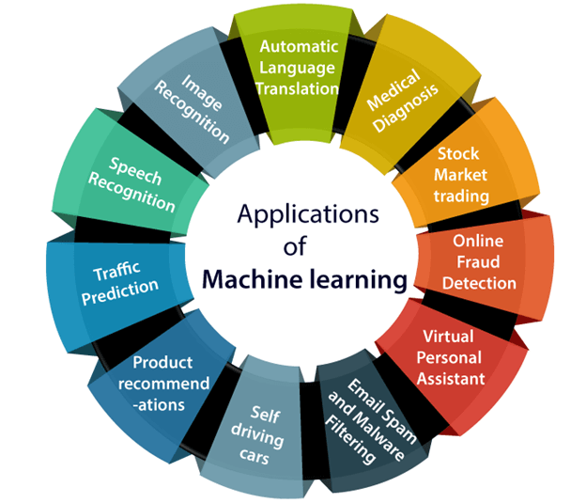

1. Image Recognition:
Image recognition is one of the most common applications of machine learning. It is used to identify objects, persons, places, digital images, etc. The popular use case of image recognition and face detection is, Automatic friend tagging suggestion:
Facebook provides us a feature of auto friend tagging suggestion. Whenever we upload a photo with our Facebook friends, then we automatically get a tagging suggestion with name, and the technology behind this is machine learning's face detection and recognition algorithm.
It is based on the Facebook project named "Deep Face," which is responsible for face recognition and person identification in the picture.

2. Speech Recognition
While using Google, we get an option of "Search by voice," it comes under speech recognition, and it's a popular application of machine learning.
Speech recognition is a process of converting voice instructions into text, and it is also known as "Speech to text", or "Computer speech recognition." At present, machine learning algorithms are widely used by various applications of speech recognition. Google assistant, Siri, Cortana, and Alexa are using speech recognition technology to follow the voice instructions.

3. Traffic prediction:
If we want to visit a new place, we take help of Google Maps, which shows us the correct path with the shortest route and predicts the traffic conditions.
It predicts the traffic conditions such as whether traffic is cleared, slow-moving, or heavily congested with the help of two ways:
- Real Time location of the vehicle form Google Map app and sensors
- Average time has taken on past days at the same time.
Everyone who is using Google Map is helping this app to make it better. It takes information from the user and sends back to its database to improve the performance.

4. Product recommendations:
Machine learning is widely used by various e-commerce and entertainment companies such as Amazon, Netflix, etc., for product recommendation to the user. Whenever we search for some product on Amazon, then we started getting an advertisement for the same product while internet surfing on the same browser and this is because of machine learning.
Google understands the user interest using various ML algorithms and suggests the product as per customer interest.As similar, when we use Netflix, we find some recommendations for entertainment series, movies, etc., and this is also done with the help of machine learning.

5. Self-driving cars:
One of the most exciting applications of machine learning is self-driving cars. Machine learning plays a significant role in self-driving cars. Tesla, the most popular car manufacturing company is working on self-driving car. It is using unsupervised learning method to train the car models to detect people and objects while driving.

6. Email Spam and Malware Filtering:
Whenever we receive a new email, it is filtered automatically as important, normal, and spam. We always receive an important mail in our inbox with the important symbol and spam emails in our spam box, and the technology behind this is Machine learning. Below are some spam filters used by Gmail:
- Content Filter
- Header filter
- General blacklists filter
- Rules-based filters
- Permission filters
Some machine learning algorithms such as Multi-Layer Perceptron, Decision tree, and Naïve Bayes classifier are used for email spam filtering and malware detection.

7. Virtual Personal Assistant:
We have various virtual personal assistants such as Google assistant, Alexa, Cortana, Siri. As the name suggests, they help us in finding the information using our voice instruction. These assistants can help us in various ways just by our voice instructions such as Play music, call someone, Open an email, Scheduling an appointment, etc.
These virtual assistants use machine learning algorithms as an important part.
These assistant record our voice instructions, send it over the server on a cloud, and decode it using ML algorithms and act accordingly.

8. Online Fraud Detection:
Machine learning is making our online transaction safe and secure by detecting fraud transaction. Whenever we perform some online transaction, there may be various ways that a fraudulent transaction can take place such as fake accounts, fake ids, and steal money in the middle of a transaction. So to detect this, Feed Forward Neural network helps us by checking whether it is a genuine transaction or a fraud transaction.
For each genuine transaction, the output is converted into some hash values, and these values become the input for the next round. For each genuine transaction, there is a specific pattern which gets change for the fraud transaction hence, it detects it and makes our online transactions more secure.

9. Stock Market trading:
Machine learning is widely used in stock market trading. In the stock market, there is always a risk of up and downs in shares, so for this machine learning's long short term memory neural network is used for the prediction of stock market trends.

10. Medical Diagnosis:
In medical science, ML is used for diseases diagnoses. With this, medical technology is growing very fast and able to build 3D models that can predict the exact position of lesions in the brain. It helps in finding brain tumors and other brain-related diseases easily.

11. Automatic Language Translation:
Nowadays, if we visit a new place and we are not aware of the language then it is not a problem at all, as for this also machine learning helps us by converting the text into our known languages. Google's GNMT (Google Neural Machine Translation) provide this feature, which is a Neural Machine Learning that translates the text into our familiar language, and it called as automatic translation.
The technology behind the automatic translation is a sequence-to-sequence learning algorithm, which is used with image recognition and translates the text from one language to another language.

UNSUPERVISED ML AND ITS TYPES
- Clustering: Clustering is the process of grouping similar data points together based on their characteristics or attributes. Clustering algorithms attempt to find patterns in the data and group the data points together based on those patterns.
- Anomaly detection: Anomaly detection is the process of identifying data points that deviate from the expected behavior of the data set. Anomaly detection algorithms attempt to identify outliers or anomalies in the data.
- Association rule learning: Association rule learning is the process of discovering relationships between variables in a data set. Association rule learning algorithms attempt to find patterns in the data that indicate that certain variables are associated with each other.
- Dimensionality reduction: Dimensionality reduction is the process of reducing the number of variables or features in a data set. Dimensionality reduction algorithms attempt to identify the most important features in the data set and remove less important ones.
- Neural Networks: In unsupervised learning, neural networks can be used for unsupervised representation learning or self-supervised learning. This allows the network to learn useful features of the data without being explicitly given a specific target.

CLUSTERING AND ITS TYPES
K-Means Clustering: It is a popular clustering algorithm that partitions the data into K clusters, where K is a user-defined number. The algorithm works by iteratively assigning data points to their nearest centroid and updating the centroid's position until convergence.
- Hierarchical Clustering: It is a clustering algorithm that builds a hierarchy of clusters by either merging small clusters into larger ones or splitting large clusters into smaller ones. There are two types of hierarchical clustering: agglomerative (bottom-up) and divisive (top-down).
- DBSCAN (Density-Based Spatial Clustering of Applications with Noise): It is a clustering algorithm that groups together points that are closely packed together, while marking outliers that lie alone in low-density regions. It works by defining a neighborhood around each data point and grouping points that are densely connected.
- Mean Shift: It is a non-parametric clustering algorithm that doesn't require specifying the number of clusters beforehand. The algorithm works by iteratively shifting a window (kernel) towards the maximum density of data points until convergence.
- Spectral Clustering: It is a clustering algorithm that uses the eigenvalues and eigenvectors of a similarity matrix to project the data onto a lower-dimensional space where it can be clustered. The algorithm works by partitioning the graph into two or more clusters based on the eigenvectors.
- Fuzzy C-Means: It is a soft clustering algorithm that assigns each data point to multiple clusters with varying degrees of membership. The algorithm works by minimizing the sum of the squared distances between the data points and their corresponding cluster centers, weighted by the membership degrees.

REINFORCEMENT LEARNING
Reinforcement learning (RL) is a type of machine learning algorithm that is used for training an agent to make decisions in an environment by interacting with it over time. The agent learns by receiving feedback in the form of rewards or penalties based on its actions, and the goal is to maximize the cumulative reward received over time. Here are the key components of a typical reinforcement learning problem:
Environment: This is the external system or process with which the agent interacts. It can be anything from a simple game environment to a complex real-world scenario such as robotics, traffic control, or finance.
Agent: This is the learner or decision-maker that interacts with the environment. The agent takes actions based on the current state of the environment and receives feedback in the form of rewards or penalties based on the outcomes of its actions.
State: This is a representation of the environment at a given point in time, which the agent uses to make decisions.
Action: This is the decision made by the agent based on the current state of the environment.
Reward: This is the feedback provided to the agent after it takes an action. The reward can be positive or negative and is used to reinforce or discourage certain behaviors.

The reinforcement learning algorithm works by having the agent interact with the environment and learn from its experiences over time. The agent starts by exploring the environment and trying different actions, and the rewards it receives are used to update its policy for taking future actions.
Reinforcement learning is used in a variety of applications, including robotics, game playing, and autonomous vehicles. It is a powerful technique that can learn complex behaviors and can be combined with other machine learning approaches such as deep learning to achieve even better results.

PROBLEM 3: A company’s marketing department collected the following data on advertising expenditure (X) and sales revenue (Y) (both in ₹’000). They want to determine the regression equation and predict sales when advertising = ₹25,000.
Observation | X (Advertising) | Y (Sales)
1 | 5 | 10
2 | 10 | 15
3 | 12 | 19
4 | 15 | 23
5 | 18 | 26
6 | 20 | 30
7 | 22 | 32
8 | 25 | 35
9 | 30 | 40
10 | 35 | 43
Solution:
X | Y | X² | XY
5 | 10 | 25 | 50
10 | 15 | 100 | 150
12 | 19 | 144 | 228
15 | 23 | 225 | 345
18 | 26 | 324 | 468
20 | 30 | 400 | 600
22 | 32 | 484 | 704
25 | 35 | 625 | 875
30 | 40 | 900 | 1200
35 | 43 | 1225 | 1505
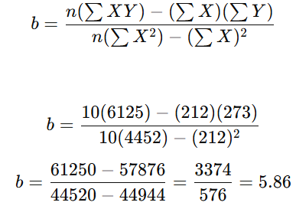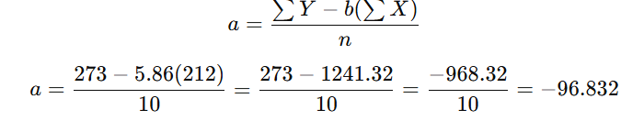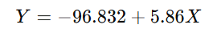
Predict sales when Advertising (X) = 25: Y = −96.832 + 5.86(25) = 49.668
Problem statement (market-basket)
T1: {Milk, Bread, Butter}
T2: {Bread, Butter, Diapers}
T3: {Milk, Bread, Diapers}
T4: {Milk, Butter, Diapers}
T5: {Bread, Diapers}
T6: {Milk, Bread, Butter}
T7: {Butter, Diapers}
T8: {Milk, Bread}
T9: {Bread, Butter, Diapers}
T10:{Milk, Diapers}

- Minimum support = 30% (for 10 transactions → min count = 3)
- Minimum confidence = 60%
Goal: find frequent itemsets and generate association rules meeting min confidence.
SOLUTION TO PROBLEM
Step 1 — Find frequent 1-itemsets (L1)
Count occurrences (support counts and support fraction):
- Milk: appears in T1, T3, T4, T6, T8, T10 → count = 6, support = 6/10 = 0.60
- Bread: T1, T2, T3, T5, T6, T8, T9 → count = 7, support = 0.70
- Butter: T1, T2, T4, T6, T7, T9 → count = 6, support = 0.60
- Diapers: T2, T3, T4, T5, T7, T9, T10 → count = 7, support = 0.70
All four items have support ≥ 0.30.
So L1 = {Milk, Bread, Butter, Diapers}.
Step 2 — Generate candidate 2-itemsets (C2) and count supports
Candidates (all pairs from L1):
- {Milk, Bread} — occurs in T1, T3, T6, T8 → count = 4, support = 0.40
- {Milk, Butter} — T1, T4, T6 → count = 3, support = 0.30
- {Milk, Diapers} — T3, T4, T10 → count = 3, support = 0.30
- {Bread, Butter} — T1, T2, T6, T9 → count = 4, support = 0.40
- {Bread, Diapers} — T2, T3, T5, T9 → count = 4, support = 0.40
- {Butter, Diapers} — T2, T4, T7, T9 → count = 4, support = 0.40
All candidate pairs meet min support count (≥3).
So L2 = {MB, MBu, MDi, BBu, BDi, BuDi} where shorthand: M=Milk, B=Bread, Bu=Butter, Di=Diapers.
Step 3 — Generate candidate 3-itemsets (C3) from L2 and count supports
Possible 3-item combos (from L2 joins):
- {Milk, Bread, Butter} — present in T1, T6 → count = 2, support = 0.20
- {Milk, Bread, Diapers} — present in T3 → count = 1, support = 0.10
- {Milk, Butter, Diapers} — present in T4 → count = 1, support = 0.10
- {Bread, Butter, Diapers} — present in T2, T9 → count = 2, support = 0.20
None of these 3-itemsets reach min support count (3). So stop here.
Final frequent itemsets = L1 and L2 (no L3).
Step 4 — Generate association rules from frequent itemsets
We generate candidate rules from frequent 2-itemsets (and could also from larger itemsets, but there are none). For each pair {X,Y} we can form two rules: X ⇒ Y and Y ⇒ X. Use the formulae:
- support(X⇒Y) = count(X ∪ Y) / N
- confidence(X⇒Y) = count(X ∪ Y) / count(X)
- lift(X⇒Y) = confidence(X⇒Y) / support(Y)
We will keep rules with confidence ≥ 0.60.
Compute for each frequent pair (counts from above; N = 10):
- {Milk, Bread} (count = 4, support = 0.40)
  - Milk ⇒ Bread
confidence = 4 / count(Milk=6) = 4/6 = 0.6667 (66.67%) → meets 0.60
lift = 0.6667 / support(Bread=0.7) = 0.6667 / 0.7 = 0.9524
  - Bread ⇒ Milk
confidence = 4 / 7 = 0.5714 → below 0.60 (discard)
- {Milk, Butter} (count = 3, support = 0.30)
  - Milk ⇒ Butter: conf = 3/6 = 0.5 → discard
  - Butter ⇒ Milk: conf = 3/6 = 0.5 → discard
- {Milk, Diapers} (count = 3, support = 0.30)
  - Milk ⇒ Diapers: conf = 3/6 = 0.5 → discard
  - Diapers ⇒ Milk: conf = 3/7 ≈ 0.4286 → discard
- {Bread, Butter} (count = 4, support = 0.40)
  - Bread ⇒ Butter: conf = 4/7 ≈ 0.5714 → discard
  - Butter ⇒ Bread: conf = 4/6 = 0.6667 → meets 0.60
lift = 0.6667 / support(Bread=0.7) = 0.9524
- {Bread, Diapers} (count = 4, support = 0.40)
  - Bread ⇒ Diapers: conf = 4/7 ≈ 0.5714 → discard
  - Diapers ⇒ Bread: conf = 4/7 ≈ 0.5714 → discard
- {Butter, Diapers} (count = 4, support = 0.40)
  - Butter ⇒ Diapers: conf = 4/6 = 0.6667 → meets 0.60
lift = 0.6667 / support(Diapers=0.7) = 0.9524
  - Diapers ⇒ Butter: conf = 4/7 ≈ 0.5714 → discard
Rules that meet confidence ≥ 60%
- Milk ⇒ Bread
  - support = 4/10 = 0.40 (40%)
  - confidence = 4/6 = 66.67%
  - lift = 0.6667 / 0.70 = 0.9524
- Butter ⇒ Bread
  - support = 4/10 = 0.40
  - confidence = 4/6 = 66.67%
  - lift = 0.9524
- Butter ⇒ Diapers
  - support = 4/10 = 0.40
  - confidence = 4/6 = 66.67%
  - lift = 0.9524
Interpretation and comments
- All three accepted rules have confidence ≈ 66.7% and lift ≈ 0.95 (slightly below 1).
- Lift < 1 indicates the consequent is actually less likely given the antecedent than at baseline — this happens because Bread and Diapers are quite common in the dataset (support = 0.7), so even a high confidence can translate into lift ≤ 1.
- In practice, high confidence should be interpreted alongside lift (and support). A high-confidence rule with lift ≈ 1 may not be very interesting because the consequent is frequent overall.
- No 3-item rules were frequent at the chosen support threshold; raising or lowering thresholds changes results.
Conclusion
- Frequent 1-itemsets (L1): {Milk (6), Bread (7), Butter (6), Diapers (7)}
- Frequent 2-itemsets (L2): {Milk–Bread (4), Milk–Butter (3), Milk–Diapers (3), Bread–Butter (4), Bread–Diapers (4), Butter–Diapers (4)}
- No frequent 3-itemsets (none reached count ≥ 3)
- Strong rules (min confidence 60%):
  - Milk ⇒ Bread (support 0.40, confidence 0.6667, lift 0.9524)
  - Butter ⇒ Bread (support 0.40, confidence 0.6667, lift 0.9524)
  - Butter ⇒ Diapers(support 0.40, confidence 0.6667, lift 0.9524)

Clustering in Data Mining
Clustering is an unsupervised data mining technique used to group a set of objects (data points) into clusters such that:
- Objects within a cluster are similar to each other, and
- Objects in different clusters are dissimilar.
Its primary goal is to identify hidden patterns and segment large datasets into smaller, meaningful groups for business applications like customer segmentation, risk management, anomaly detection, customer behaviour analysis, strategic decision making in business and pattern recognition.
Objectives of Clustering
- Identify hidden patterns in data.
- Discover customer segments or behavior groups.
- Reduce data complexity by summarizing large datasets.
- Support decision-making, marketing, and risk management.
Use of Clustering in Business Applications
Clustering is used across business domains for segmentation, prediction, and optimization.
Business Area | Clustering Application | Example
Marketing | Customer segmentation based on purchasing behavior | Group customers into segments like “high-value”, “frequent”, “occasional buyers”.
Retail | Market basket analysis; store layout design | Identify products often bought together and cluster stores by sales performance.
Banking and Finance | Risk assessment and fraud detection | Cluster customers based on credit risk or transaction patterns.
Healthcare | Patient profiling and disease pattern discovery | Group patients by symptoms, treatment response, or age.
Insurance | Claim analysis and policy grouping | Identify clusters of high-risk or low-risk policyholders.
Telecommunications | Customer churn prediction | Group customers based on usage and retention behavior.
Methods of Clustering
There are several clustering approaches, each based on how the similarity between data points is defined and how clusters are formed.
a) Partitioning Methods
These methods divide data into k non-overlapping clusters directly.
Each cluster is represented by a centroid (mean point).

Algorithm: K-Means Clustering
- Choose number of clusters k.
- Initialize k cluster centers (randomly).
- Assign each data point to the nearest centroid (using distance measure like Euclidean distance).
- Recompute centroids as the mean of points in each cluster.
- Repeat until centroids stabilize.
Example: A retail company uses K-Means to group 1,000 customers into 3 segments:
- Cluster 1: Price-sensitive customers
- Cluster 2: Brand-loyal customers
- Cluster 3: Occasional buyers

b) Hierarchical Clustering Methods
Builds a hierarchy (tree structure) of clusters, known as a dendrogram.
Example:
In customer data, hierarchical clustering may reveal:
- Level 1: High-value vs. low-value customers
- Level 2: Within high-value → online vs. in-store buyers
Problem
Given the 9 two-dimensional points below, cluster them into k = 3 clusters using K-Means.
ID | (X, Y)
P1 | (2, 10)
P2 | (2, 5)
P3 | (8, 4)
P4 | (5, 8)
P5 | (7, 5)
P6 | (6, 4)
P7 | (1, 2)
P8 | (4, 9)
P9 | (3, 3)
Initial centroids (chosen):
C1 = (2, 10) (use P1)
C2 = (5, 8) (use P4)
C3 = (1, 2) (use P7)
Step 1: Initial Setup
We had 9 data points (P1–P9), each defined by (X, Y) coordinates.
We chose k = 3, so we needed 3 initial centroids:
- C1 = (2, 10)
- C2 = (5, 8)
- C3 = (1, 2)
We will calculate Euclidean distance of each point from all 3 centroids and assign the point to the nearest centroid (i.e., the smallest distance).
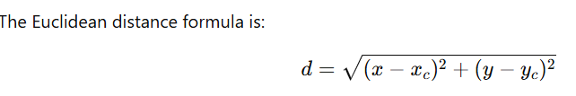
Step 2: Iteration 1 — Distance Calculations and Assignments
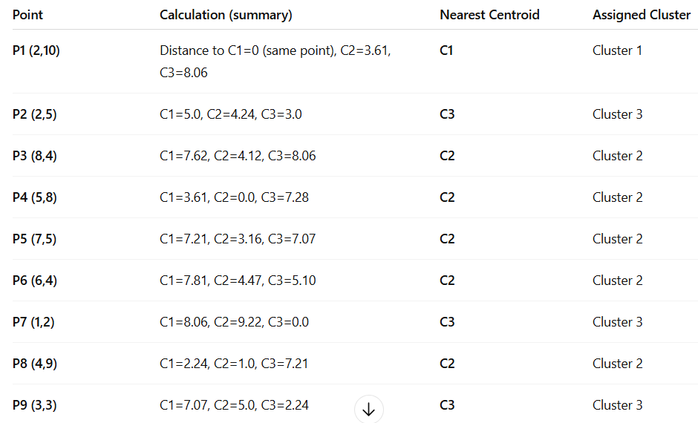
Thus, after Iteration 1:
- Cluster 1: {P1}
- Cluster 2: {P3, P4, P5, P6, P8}
- Cluster 3: {P2, P7, P9}
Recompute centroids (after Iteration 1)
Compute the mean (average) of X and Y for points in each cluster.
- New C1 = mean of {P1} = (2, 10)
- New C2 = mean of {P3(8,4), P4(5,8), P5(7,5), P6(6,4), P8(4,9)}
  - Xmean = (8+5+7+6+4)/5 = 30/5 = 6.0
  - Ymean = (4+8+5+4+9)/5 = 30/5 = 6.0
→ New C2 = (6.0, 6.0)
- New C3 = mean of {P2(2,5), P7(1,2), P9(3,3)}
  - Xmean = (2+1+3)/3 = 6/3 = 2.0
  - Ymean = (5+2+3)/3 = 10/3 ≈ 3.333333...
→ New C3 = (2.0, 3.333333...)

Iteration 2 — Reassign using new centroids
Centroids now: C1= (2,10), C2 = (6,6), C3=(2,3.3333)
Compute distances and assign:
Point | d to C1 | d to C2 | d to C3 | Assigned cluster
P1 (2,10) | 0.00 | 5.39 | 6.90 | C1
P2 (2,5) | 5.00 | 4.12 | 1.67 | C3
P3 (8,4) | 7.62 | 2.83 | 6.08 | C2
P4 (5,8) | 3.61 | 2.24 | 5.70 | C2
P5 (7,5) | 7.21 | 1.41 | 5.10 | C2
P6 (6,4) | 7.81 | 2.24 | 4.47 | C2
P7 (1,2) | 8.06 | 6.71 | 1.67 | C3
P8 (4,9) | 2.24 | 3.16 | 5.85 | C1
P9 (3,3) | 7.07 | 3.61 | 0.67 | C3

Cluster membership after Iteration 2:
- Cluster 1 (C1): {P1, P8}
- Cluster 2 (C2): {P3, P4, P5, P6}
- Cluster 3 (C3): {P2, P7, P9}
Recompute centroids (after Iteration 2)
- New C1 = mean of {P1(2,10), P8(4,9)}
  - Xmean = (2+4)/2 = 3.0
  - Ymean = (10+9)/2 = 9.5
→ C1 = (3.0, 9.5)
- New C2 = mean of {P3(8,4), P4(5,8), P5(7,5), P6(6,4)}
  - Xmean = (8+5+7+6)/4 = 26/4 = 6.5
  - Ymean = (4+8+5+4)/4 = 21/4 = 5.25
→ C2 = (6.5, 5.25)
- New C3 = mean of {P2(2,5), P7(1,2), P9(3,3)} (unchanged)
→ C3 = (2.0, 3.333333...) = (2, 3.33)

Iteration 3 — Reassign using centroids C1=(3.0,9.5), C2=(6.5,5.25), C3=(2.0,3.3333)
Point | d to C1 | d to C2 | d to C3 | Assigned cluster
P1 (2,10) | 1.12 | 5.39 | 6.90 | C1
P2 (2,5) | 4.72 | 4.80 | 1.67 | C3
P3 (8,4) | 7.28 | 1.30 | 6.08 | C2
P4 (5,8) | 1.80 | 2.96 | 5.70 | C1
P5 (7,5) | 6.10 | 1.75 | 5.10 | C2
P6 (6,4) | 6.40 | 1.25 | 4.47 | C2
P7 (1,2) | 8.79 | 6.10 | 1.67 | C3
P8 (4,9) | 0.50 | 3.97 | 5.85 | C1
P9 (3,3) | 6.53 | 3.20 | 0.67 | C3

Cluster membership after Iteration 3:
- Cluster 1 (C1): {P1, P4, P8}
- Cluster 2 (C2): {P3, P5, P6}
- Cluster 3 (C3): {P2, P7, P9}

Recompute centroids (after Iteration 3)
- New C1 = mean of {P1(2,10), P4(5,8), P8(4,9)}
  - Xmean = (2+5+4)/3 = 11/3 = 3.6666667
  - Ymean = (10+8+9)/3 = 27/3 = 9.0
→ C1 = (3.6667, 9.0)
- New C2 = mean of {P3(8,4), P5(7,5), P6(6,4)}
  - Xmean = (8+7+6)/3 = 21/3 = 7.0
  - Ymean = (4+5+4)/3 = 13/3 ≈ 4.3333333
→ C2 = (7.0, 4.3333)
- New C3 = mean of {P2(2,5), P7(1,2), P9(3,3)} (unchanged)
→ C3 = (2.0, 3.3333333)
Iteration 4 — Reassign using centroids C1=(3.6667,9.0), C2=(7.0,4.3333), C3=(2.0,3.3333)
Compute distances (summary):
- After computing distances, each point remains assigned as in Iteration 3:
Cluster membership after Iteration 4:
- Cluster 1: {P1, P4, P8}
- Cluster 2: {P3, P5, P6}
- Cluster 3: {P2, P7, P9}
Because assignments did not change, the algorithm has converged.
Final result (clusters and centroids)
Cluster A (Centroid ≈ (3.6667, 9.0))
Points: P1 (2,10), P4 (5,8), P8 (4,9)
Cluster B (Centroid ≈ (7.0, 4.3333))
Points: P3 (8,4), P5 (7,5), P6 (6,4)
Cluster C (Centroid ≈ (2.0, 3.3333))
Points: P2 (2,5), P7 (1,2), P9 (3,3)
Interpretation (business/analytical)
- Cluster A groups the high-Y values (customers with high “Y” metric such as high spending) — good candidates for premium offers.
- Cluster B groups medium X, low Y (e.g., medium income but moderate purchases).
- Cluster C groups low X and low Y (low-income/low-spend customers).
K-Means successfully partitioned the dataset into three coherent groups that can be used for targeted strategies (marketing, inventory, personalization).
Problem on Regression
calculate a and b by solving the normal equations of the linear regression curve.

CLUSTER ANALYSIS (CLUSTERING)
It is an unsupervised learning technique used in data mining to group a set of objects into clusters (groups) such that objects in the same cluster are more similar to each other than to those in other clusters. It helps uncover hidden patterns, relationships, or structures in data without predefined labels.
The goal is to ensure that data points within a cluster are more similar to each other than to those in other clusters. For example, in e-commerce retailers use clustering to group customers based on their purchasing habits. If one group frequently buys fitness gear while another prefers electronics. This helps companies to give personalized recommendations and improve customer experience. It is useful for:
- Scalability: It can efficiently handle large volumes of data.
- High Dimensionality: Can handle high-dimensional data.
- Adaptability to Different Data Types: It can work with numerical data like age, salary and categorical data like gender, occupation.
- Handling Noisy and Missing Data: Usually, datasets contain missing values or inconsistencies and clustering can manage them easily.
- Interpretability: Output of clustering is easy to understand and apply in real-world scenarios.
Points to Remember:
One group is treated as a cluster of data objects
- In the process of cluster analysis, the first step is to partition the set of data into groups with the help of data similarity, and then groups are assigned to their respective labels.
- The biggest advantage of clustering over-classification is it can adapt to the changes made and helps single out useful features that differentiate different group
Characteristics of Clustering
- Unsupervised Learning: No predefined output variable — clusters are formed based on data similarity.
- Similarity-based Grouping: Objects are grouped using distance or similarity measures (e.g., Euclidean distance, Manhattan distance).
- Intra-cluster similarity (high): Items in the same cluster are very similar.
- Inter-cluster similarity (low): Items in different clusters are as different as possible.
- Scalability: Should efficiently handle large datasets.
- Interpretability: Resulting clusters should be meaningful and easy to interpret.
- Automatic Classification: Data points are automatically grouped without human intervention.
Business Applications of Clustering
Domain | Use Case
Marketing & Customer Segmentation | Identify customer groups based on purchasing behavior.
Retail & E-commerce | Product recommendation and basket analysis.
Banking & Finance | Credit scoring, fraud detection, and customer profiling.
Healthcare | Group patients with similar symptoms or medical history.
Insurance | Risk assessment and claim pattern analysis.
Telecom | Identifying churn segments and usage patterns.
Uses of cluster analysis:
- It is widely used in many applications such as image processing, data analysis, and pattern recognition.
- It helps marketers to find the distinct groups in their customer base and they can characterize their customer groups by using purchasing patterns.
- It can be used in the field of biology, by deriving animal and plant taxonomies and identifying genes with the same capabilities.
- It also helps in information discovery by classifying documents on the web.
Distance Metrics
Distance metrics are simple mathematical formulas to figure out how similar or different two data points are. Type of distance metrics we choose plays a big role in deciding clustering results. Some of the common metrics are:
- Euclidean Distance: It is the most widely used distance metric. It is defined as the distance between two points in Euclidean space. To find the distance between two points, the length of the line segment that connects the two points should be measured.
- It is like measuring the straightest and shortest path between two points. This metric is widely utilized in various fields such as machine learning, data analysis, computer vision, and many more applications of AI and ML.

Euclidean Distance Formula
Consider two points (x1, y1) and (x2, y2) in a 2-dimensional space; the Euclidean Distance between them is given by using the formula:
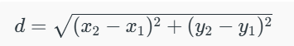
Euclidean Distance in 3D
If the two points (x1, y1, z1) and (x2, y2, z2) are in a 3-dimensional space, the Euclidean Distance between them is given by using the formula:
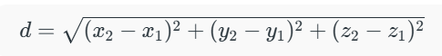
Manhattan Distance: It measures the distance between two points based on grid-like path. It adds the absolute differences between the values.
The Manhattan Distance between two points (X1, Y1) and (X2, Y2) is given by |X1 – X2| + |Y1 – Y2|. An example is as follows:
Input: arr[] = {(1, 2), (2, 3), (3, 4)}
Output: 4
Explanation:
The maximum Manhattan distance is found between (1, 2) and (3, 4) i.e.,
|3 - 1| + |4- 2 | = 4.
K-Nearest Neighbour(KNN) Algorithm
KNN is a supervised ML algorithm generally used for classification but can also be used for regression tasks. It works by finding the "k" closest data points (neighbors) to a given input and makes predictions based on the majority class (for classification) or the average value (for regression).
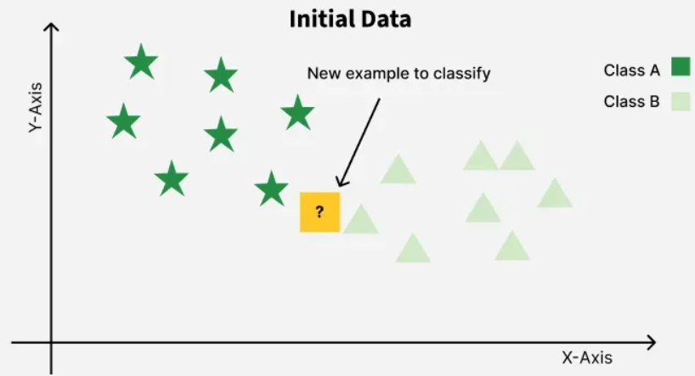
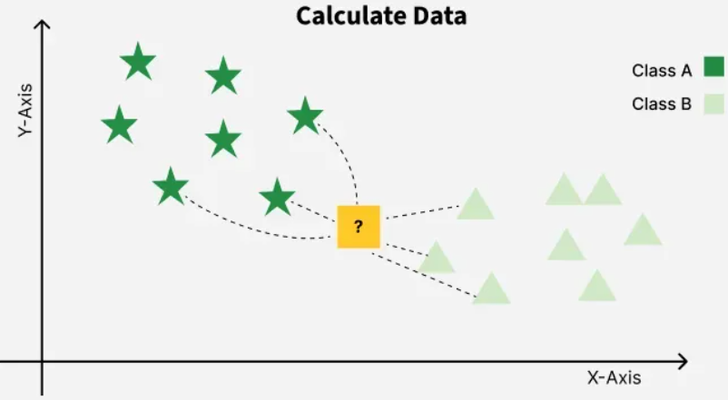

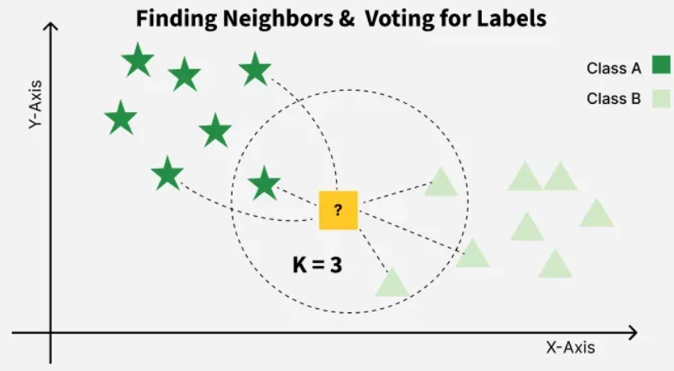
What is the K-Nearest Neighbors Algorithm?
- KNN is one of the most basic yet essential classification algorithms in machine learning. It belongs to the supervised learning domain and finds intense application in pattern recognition, data mining, and intrusion detection.
- It is widely disposable in real-life scenarios since it is non-parametric, meaning it does not make any underlying assumptions about the distribution of data (as opposed to other algorithms such as GMM, which assume a Gaussian distribution of the given data). We are given some prior data (also called training data), which classifies coordinates into groups identified by an attribute.
- As an example, consider the following table of data points containing two features:
KNN is also called as a lazy learner algorithm because it does not learn from the training set immediately instead it stores the entire dataset and performs computations only at the time of classification. For example, consider the following table of data points containing two features:
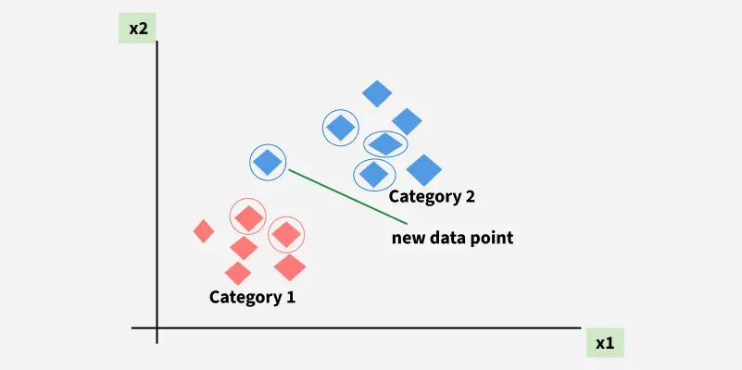
The new point is classified as Category 2 because most of its closest neighbours are blue squares. KNN assigns category based on the majority of nearby points.
- The red diamonds represent Category 1 and the blue squares represent Category 2.
- The new data point checks its closest neighbors (circled points).
- Since the majority of its closest neighbors are blue squares (Category 2) KNN predicts the new data point belongs to Category 2.
KNN works by using proximity and majority voting to make predictions.
What is 'K' in K Nearest Neighbour?
In the k-Nearest Neighbours algorithm k is just a number that tells the algorithm how many nearby points or neighbours to look at when it makes a decision.
Example: Imagine you're deciding which fruit it is based on its shape and size. You compare it to fruits you already know.
- If k = 3, the algorithm looks at the 3 closest fruits to the new one.
- If 2 of those 3 fruits are apples and 1 is a banana, the algorithm says the new fruit is an apple because most of its neighbours are apples.

How to choose the value of k for KNN Algorithm?
- The value of k in KNN decides how many neighbours the algorithm looks at when making a prediction. Choosing the right k is important for good results.
- If the data has lots of noise or outliers, using a larger k can make the predictions more stable.
- But if k is too large the model may become too simple and miss important patterns and this is called underfitting.
- So k should be picked carefully based on the data. Rule of thumb: k≈ √n​

Why KNN Algorithm
- kNN algorithm is a simple, non-parametric, and instance-based machine learning method used for classification and regression. It does not require any assumptions about the underlying data distribution; can also handle both numerical and categorical data.
- Makes predictions based on the similarity of data points in a given dataset. K-NN is less sensitive to outliers compared to other algorithms. It works by finding the K nearest neighbours to a given data point based on a distance metric, such as Euclidean distance, which measures the similarity between data points.
- The class or value of the data point is then determined by the majority vote or average of the K neighbours. This approach allows algorithm to adapt to different patterns and make predictions based on the local structure of the data.
Steps in kNN using Euclidean Distance
- Compute Euclidean distance between query point and all points in the dataset.
- Sort the distances in ascending order.
- Select the k closest points (nearest neighbors).
- Classify (for classification tasks) by majority voting among the k neighbors
- Predict by averaging the values of the k nearest neighbors

PROBLEM 1 : We have the following dataset with two features (X₁, X₂) and class labels (0 or 1). Classify a query point (3, 3) using k = 3 and Euclidean distance?
Point (X₁, X₂) | Class
(1, 2) | 0
(2, 3) | 0
(3, 4) | 1
(5, 6) | 1

Step 1: Compute Euclidean Distance
Euclidean distance between two points A(X₁, X₂) and B(Y₁, Y₂) is
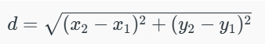

Calculate distances from (3,3) to each point in the dataset:
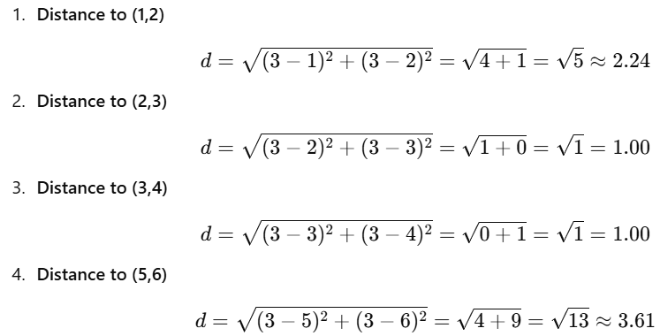
Step 2: Sort Distances
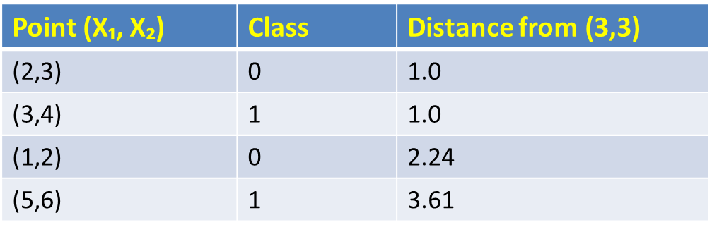
Step 3: Select k Nearest Neighbours
For k=3, the closest 3 points are as follows:
(2,3) → Class 0
(3,4) → Class 1
(1,2) → Class 0
Step 4: Select k Nearest Neighbours
Class 0 : 2 votes
Class 1 : 1 vote
Since Class 0 has the majority, we classify (3,3) as Class 0.
Answer : The query point (3, 3) belongs to Class 0.
EXAMPLE 2 : We’ll classify a new 2-D point x₀ = (4,4) using kNN with k = 3 and also with k=5. We will compute distances digit-by-digit to avoid mistakes.
ID | x1 | x2 | Class
A | 1 | 2 | Red
B | 2 | 3 | Red
C | 3 | 1 | Blue
D | 6 | 5 | Blue
E | 7 | 7 | Blue
F | 8 | 6 | Blue
Step 1 — compute Euclidean distances to each training point
Distance between (4,4) and A (1,2) = √(9 + 4) = √13 = 3.61
Distance between (4,4) and B (2,3) = √(4 + 1) = √5 = 2.24
Distance between (4,4) and C (3,1) = √(1 + 9) = √10 = 3.16
Distance between (4,4) and D (6,5) = √(4 + 1) = √5 = 2.24
Distance between (4,4) and E (7,7) = √(9 + 9) = √18 = 4.24
Distance between (4,4) and F (8,6) = √(16 + 4) = √20 = 4.48
Step 2 — sort neighbors by distance
Sorted distances (nearest first):
Sorted distances (nearest first):
- B: 2.24 — Class = Red
- D: 2.24 — Class = Blue
- C: 3.16 — Class = Blue
- A: 3.61 — Class = Red
- E: 4.24 — Class = Blue
- F: 4.48 — Class = Blue
(Notice B and D are tied at ≈2.23607; handle ties by including both — fine since k will include both.)
Case 1: k = 3 (majority vote)
Top 3 neighbors: B (Red), D (Blue), C (Blue)
Counts:
- Blue: 2 (D, C)
- Red: 1 (B)
Majority → Blue. 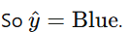
Case 2: k = 5 (majority vote)
Top 5 neighbors: B (Red), D (Blue), C (Blue), A (Red), E (Blue)
Counts:
- Blue: 3 (D, C, E)
- Red: 2 (B, A)
Majority → Blue.
Problem3 :
We had a dataset of six representing students' study habits and their exam results. We need to classify a new student (S₇) with this data :
Hours of Study = 3, Classes Attended = 7 using k=3 (i.e., look for 3 nearest neighbors).
Student | Hours of Study (X₁) | Number of Classes Attended (X₂) | Result (Y)
S₁ | 7 | 7 | Pass
S₂ | 7 | 4 | Pass
S₃ | 3 | 4 | Fail
S₄ | 1 | 4 | Fail
S₅ | 2 | 3 | Fail
S₆ | 6 | 6 | Pass
Solution : Step 1: Compute Euclidean Distances from (3,7)
Student | Coordinates | Distance from S₇ (3,7) | Result
S₁ | (7,7) | √((7−3)² + (7−7)²) = √(16 + 0) = 4.00 | Pass
S₂ | (7,4) | √((7−3)² + (4−7)²) = √(16 + 9) = 5.00 | Pass
S₃ | (3,4) | √((3−3)² + (4−7)²) = √(0 + 9) = 3.00 | Fail
S₄ | (1,4) | √((1−3)² + (4−7)²) = √(4 + 9) = 3.61 | Fail
S₅ | (2,3) | √((2−3)² + (3−7)²) = √(1 + 16) = 4.12 | Fail
S₆ | (6,6) | √((6−3)² + (6−7)²) = √(9 + 1) = 3.16 | Pass
Step 2: Sort by Distance (Nearest to Farthest)
Rank | Student | Distance | Result
1 | S₃ | 3.00 | Fail
2 | S₆ | 3.16 | Pass
3 | S₄ | 3.61 | Fail
4 | S₁ | 4.00 | Pass
5 | S₅ | 4.12 | Fail
6 | S₂ | 5.00 | Pass
Step 3: Select k = 3 Nearest Neighbours
The 3 nearest neighbours to S₇ are:
Student | Distance | Result
S₃ | 3.00 | Fail
S₆ | 3.16 | Pass
S₄ | 3.61 | Fail

Step 4: Apply Majority Voting Rule
Among the 3 nearest neighbours:
- Fail = 2 (S₃ and S₄)
- Pass = 1 (S₆)
Therefore, the predicted result for S₇ = Fail
Step 5: Interpretation
This means: A student who studies 3 hours and attends 7 classes is likely to Fail, based on the patterns learned from historical data.
Advantages of kNN
- Simple and intuitive (no complex model training).
- Effective for small datasets.
- Works well when decision boundaries are irregular.
Limitations
- Computatssionally expensive for large datasets (distance must be computed for all points).
- Sensitive to irrelevant or scaled features.
- Performance depends on the right choice of k and distance metric.
Pros
- Simple to understand and implement.
- No parametric assumptions about data distribution.
- Naturally handles multi-class problems.
- Flexible: choice of distance and weighting.
Cons
- Slow at prediction time for large datasets (unless optimized).
- Memory intensive (store entire training set).
- Sensitive to irrelevant features and feature scaling.
- Performance deteriorates in high dimensions.
Uses / Applications of KNN Rule in business and industry
- Customer classification: label a new customer into segments based on past customers.
- Credit scoring: nearest historical borrowers to estimate default risk.
- Recommendation (cold-start): content/item similarity (kNN on item features).
- Fraud detection: compare transaction to neighbors to spot anomalies.
- Medical diagnosis: classify patient condition from clinical measurements.
- Image recognition (classical): nearest-neighbor on feature descriptors.
Example: Table shows the number of motor registrations in a certain territory for a term of 5 years and the sale of tyres by a firm in that territory
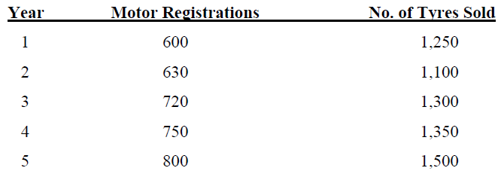
Find the regression equation to estimate the sale of tyres when motor registration is known. Estimate sale of tyres when registration is 850.
Solution: We take registrations as X and tyre sales as Y. To find line of Y on X.
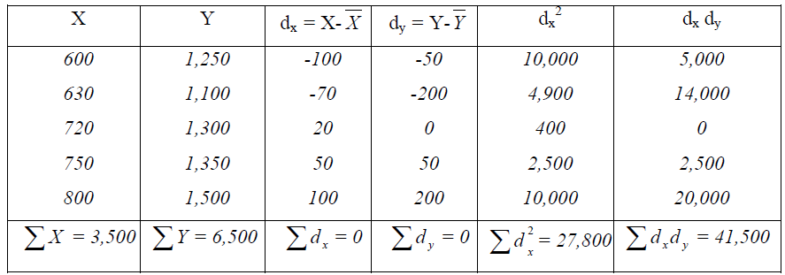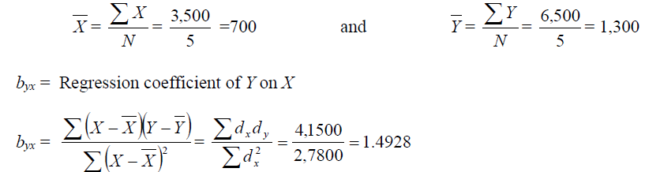
The regression line of Y on X is given by the equation:
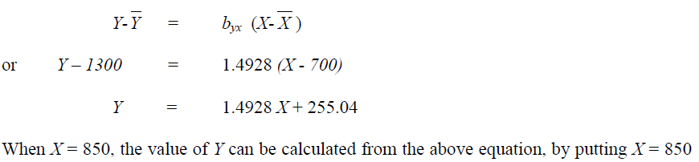
Y = (1.4928 x 850) + 255. 04 = 1523.92 = 1524 tyres

Example: For some bivariate data, the following results were obtained
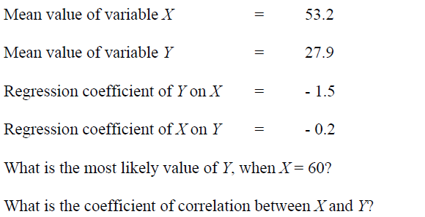
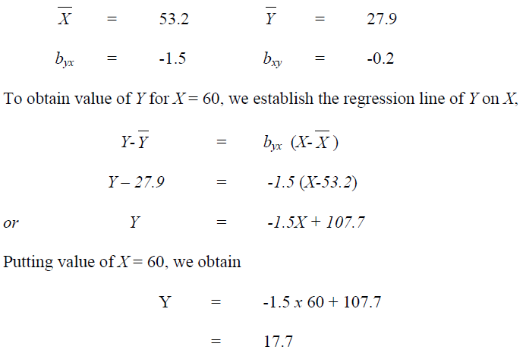
Coefficient of correlation between X, Y is given by r² = b_{yx} . b_{xy}
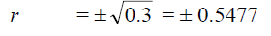
Since both regression coefficients are negative, we assign negative value to correlation coefficient r, and so r = -0.5477

